Health and Safety at work Policy
Employer duties
- It is an employer's duty to protect the health, safety and welfare of their employees and other people who might be affected by their business. EYAI must do whatever is reasonably feasible to achieve this. This means making sure that you and others are protected from anything that may cause harm, effectively controlling any risks to injury or health that could arise in the workplace.

- EYAI has duties under health and safety law to assess risks in the workplace. Risk assessments should be carried out that the address you are working to reduce risks that may cause harm in your workplace. EYAI must give you information about the risks in your workplace and how you are protected, and make sure you are instructed and trained on how to deal with the risks, setting up emergency procedures where required.

- Your employer must consult you on health and safety issues, either directly or through a safety representative that is either elected by the trustees or through the employer you are working for.

- Report injuries, diseases and dangerous occurrences to the appropriate authority, as required under the Reporting of Injuries, Diseases and Dangerous Occurrences Regulations (RIDDOR).

- Provide adequate welfare and first aid facilities, let you know who the first aiders are.

- Provide protective clothing and equipment free of charge - Personal Protective Equipment (PPE) and Personal Protective Clothing (PPE).

- Go through the health and safety policy statement in your first day induction.

- Avoid the risk of injury from manual handling operations.

- The employer must consult employees on any changes that affect health and safety.

Employee responsibilities
You must:
- Take all reasonable care to maintain your own health and safety and that of others who may be affected by your actions or failure to take action. The ‘others ‘may include: fellow workers, contractors, visitors, service users etc.

- Report any hazards and risks

- Use personal protective clothing where required (PPC)

- Co-operate with your employer on all aspects of health, safety and welfare by attending training sessions, following instructions, participating on health and safety committees.

- Act responsibly by not tampering with or misusing equipment provided for health and safety purposes.
Most of us use equipment or tools of some description in our daily work. Employees also have the duty to undertake any necessary training required to use such equipment, to operate equipment safely and to co-operate with employer procedures for dealing with and reporting faults.
An employer with five employees or more must have in writing:
A policy statement that clarifies its aims and purpose (A statement of intent). The organisation is required to implement the policy saying who is responsible for what (showing accountability).
Arrangements, systems and procedures to ensure that work is carried out safely.
The Health and Safety at Work Act 1974 does not in itself cover everything that should be considered and has been built on and amended by other legislation which uses it as a starting point.
The principal regulations made with reference to the 1974 Act:
- Workplace (Health, Safety and Welfare) Regulations 1992
- Health and Safety (Safety Signs and Signals) 1996
- Reporting Injuries, Diseases and Dangerous Occurrences (RIDDOR) Regulations 1995
- The Control of Substances Hazardous to Health Regulations 2002 (COSHH)

The Workplace (Health, Safety and Welfare) Regulations 1992
These regulations state that the employer’s premises must not be a risk to employees. They are concerned with general safety in the workplace and not in particular just machines and activities.
This covers the building itself and four other main areas:
- The working environment
- Safety
- Facilities
- Housekeeping

Main points to consider:
Building structure: - Design, Traffic, Ventilation, Temperature, Lighting

Safety

Workstations
These should be designed to be safe and comfortable, e.g. controls should be within easy reach, a suitable seat and footrest should be provided (if the task can be accomplished seated).

Floors
These should be constructed of suitable material and regularly maintained to prevent slipping and falling. Arrangements should be made to minimise risk from snow and ice.

Doors and windows
Should be suitably constructed and all should function safely. Suitable provisions should be made for the cleaning of windows and skylights. The appropriate precautions should be taken to prevent anyone falling from a window.

Storage and racking
The design of any storage areas is important to help to ensure safety in the workplace. Keeping areas clean and tidy will help to reduce the risk of incidents or accidents.

Escalators and travelators
These should have safety devices such as emergency stops, to help prevent trapping. These safety devices should be easily identifiable.

Doors and Gates
Doors must be properly constructed and have proper safety devices. Transparent doors must be appropriately marked and be constructed of safe material. Power-operated doors must have a means to prevent people being trapped and if power fails, the doors should be able to be opened manually.

Falls from heights, falls into dangerous substances and falling objects
The likelihood of people falling from height must be prevented by having appropriate guard rails. Falls from access ways over vats, tanks, silos etc. should be prevented by having walkways fitted with toe boards and rails. Vessels containing hazardous substances should have a cover and precautions should be taken to prevent injury from falling objects.

Welfare Facilities
Workplaces must be provided with:
- Suitable and sufficient toilets and washing facilities, including provision for the disabled
- An adequate supply of drinking water
- Facilities for clothing storage and changing facilities where required
- Facilities for pregnant and nursing mothers
- Facilities for people at work to eat meals

Cleanliness
Your workplace should be kept clean at all times this includes all furniture, fittings, walls, floors and ceilings.

Spillages
Spills must be cleaned and removed immediately and waste material (rubbish), should not be allowed to accumulate and become a potential fire hazard or health risk; for example, oil, fat, dressings and sharps should be disposed of in appropriate containers.
Health and Safety (Safety Signs and Signals) regulations 1996
These regulations state that if, after a risk assessment, risks still remain, then warning signs must be posted. All signs must be well maintained, it is also important for employers to provide information on what the signs mean and what action needs to be taken.
There are four types of coloured signs with specific meanings:
Colour | Meaning
Red Border on a white circle with a red band crossing through the symbol | PROHIBITED! - something you must not do.
Yellow Triangle with black border and symbols | WARNING - Take care, proceed with caution
Blue circle with white symbols | MANDATORY - Something you MUST do
Green square or rectangle with white symbols | SAFETY - An escape route or first aid post
Enforcement will be carried out either by the Health & Safety Executive (HSE) or by the relevant local authority, depending on the nature of the business.
Inspectors are given many powers under the Health and Safety at Work Act, to enable them to carry out their work effectively, such as:
- Access to any workplace at any reasonable time
- Direct that locations remain undisturbed after an accident
- Ask questions and give advice
- Take measurements, photographs and samples
- Order the removal and testing of equipment
- Instigate legal proceedings for failure to comply with notices

Reporting accidents and ill health at work is a legal requirement.
The information enables organisations such as the HSE to identify trends and areas of high risk.
Overall it is to help protect everyone by reducing risk in the workplace.

This will be done by the department first aider which must be recorded in the accident book who will also notify EYAI mentor to record.
The first aider and mentor will need to have some clear definitions of different types of injury so that you know just what to report. This is addressed as we carry on.

What is a major injury for reporting purposes?
- Fracture other than to fingers, thumbs or toes;
- Amputation;
- Dislocation of the shoulder, hip, knee or spine;
- Loss of sight (temporary or permanent);
- Chemical or hot metal burn to the eye or any penetrating injury to the eye;
- Injury resulting from an electric shock or electrical burn - leading to unconsciousness or requiring resuscitation or requiring admittance to hospital for more than 24 hours;
- Unconsciousness caused by asphyxia or exposure to a harmful substance or biological agent;
- Acute illness requiring medical treatment or loss of consciousness arising from absorption of any substance by inhalation, ingestion or through the skin;
- Acute illness requiring medical treatment where there is reason to believe that this resulted from exposure to a biological agent or its toxins or infected material.
- The over three-day reporting requirement for people injured at work changed on the 6th of April 2012 from over 3 days to more than seven days.
This change now means that injuries only need to be reported that:
- “lead to an employee or self-employed person being away from work, or unable to perform their normal work duties, for more than seven consecutive days as the result of an occupational accident or injury (not counting the day of the accident but including weekends and rest days)”.
- The associated report must be made within 15 days of the accident.
- If the worker has been incapacitated for more than three consecutive days, a record must still be kept about the accident.
- “If you are an employer, who must keep an accident book under the Social Security (Claims and Payments) Regulations 1979, that record will be enough”
- for more information, please visit:
- http://www.hse.gov.uk/riddor/what-must-i-report.htm
Ranges of diseases that are reportable.
Diseases need only be reported when the employees doctor informs the employer in writing that the employee has contracted a reportable disease. The employer must report it to the HSE Incident Contact Center. The employer will also contact EYAI mentor to record.

What diseases must you report?
- Certain types of poisoning
- Tinnitus
- Some skin diseases such as: occupational dermatitis, skin cancer, chrome ulcer, oil folliculate/ acne
- Lung diseases including occupational asthma, farmer’s lung, pneumoconiosis, asbestosis, mesothelioma
- Infections such as Leptospirosis, hepatitis, tuberculosis, anthrax, legionella and tetanus; and more recently MRSA. Clostridium Difficile
What is a dangerous occurrence?
Any incident that happens that threatens life or limb but actually results in a near miss with no-one injured.
It’s important to record all the detailed information in order to try and make sure that this can’t happen again, because next time, who knows what the injury count could be.
A few examples could be
- a collision of vehicles within the workplace which could have resulted in fatalities or major injuries
- contact of equipment with power cables
- a fire that prevents work for longer than 24 hours.
If an occurrence is classified as reportable, the HSE must be notified whether or not anyone is injured.
Records of anything classified as reportable must be kept for a minimum of 3 years.

What records must be kept?
A record of any reportable injury, disease or dangerous occurrence must be kept for three years after the date on which it happened, this must include:
- The date and method of reporting:
- The date, time and place of the event;
- Personal details of those involved;
- A brief description of the nature of the event or diseases.

The Control Of Substances Hazardous To Health Regulations (COSHH)
It is important to show your understanding of the COSHH regulations and be able to identify hazardous substances and how to control them.
COSHH requires employers to:
- control exposure to hazardous substances
- protect both employees and others who may be exposed during work activities

What are Hazardous substances?
Hazardous substances include anything that can harm your health when you work with them. They are found in nearly all work places and include:
- Substances used directly in work activities e.g. glues, paints, cleaning agents.
- Substances generated during work activities e.g. fumes from soldering, welding and mixing cleaning substances together.
- Naturally occurring substances e.g. grain dust, bodily fluids, bacteria.
- Vapours.
- Any dangerous substance listed as part 1 of the approved supply/carriage list. (The packaging number indicates the degree of danger from 1-great danger, 11-medium danger-111- minor danger).
- Any substance given a Workplace Exposure Limit (WEL).
If the packaging has any of the hazard symbols printed on it, then it is classed as a hazardous substance. For the vast majority of commercial chemicals, the presence (or not) of a warning label will indicate whether COSHH is relevant. For example:
Household washing up liquid does not have a warning label but bleach does. So, COSHH applies to bleach but not to washing up liquid (when used at work).

Typical Hazard Warning Symbols
To ensure you are aware of and can recognise the relevant warning signs and symbols, familiarise
yourself with those found below, as these are typical symbols that identify danger or denote the different
types of hazardous substances.
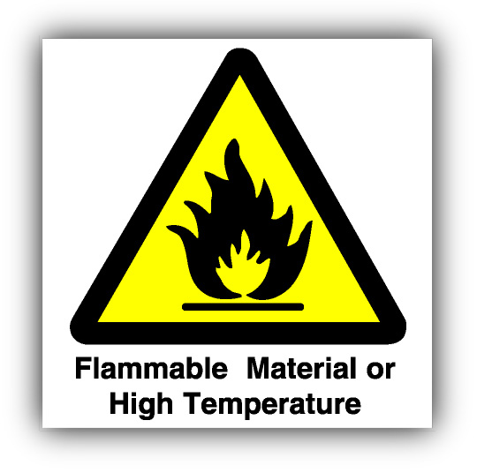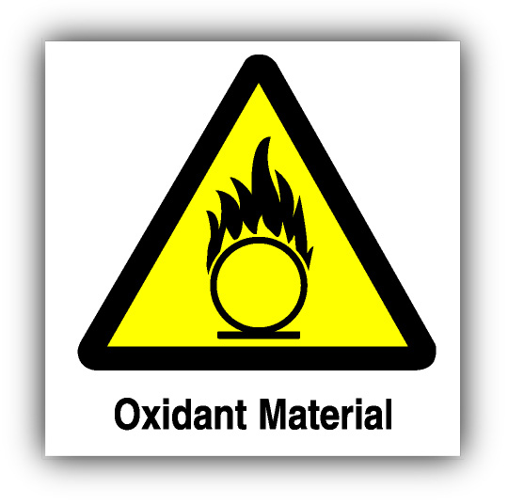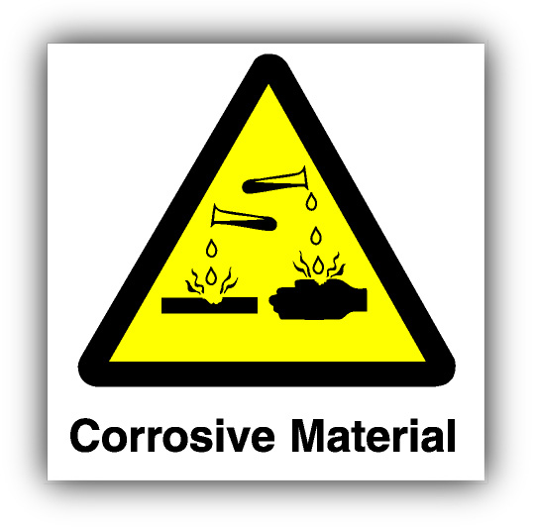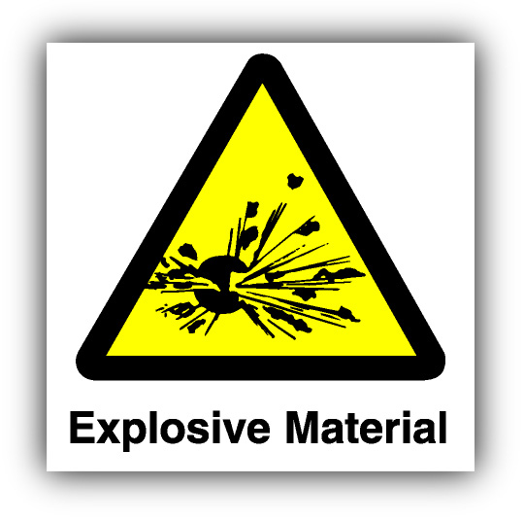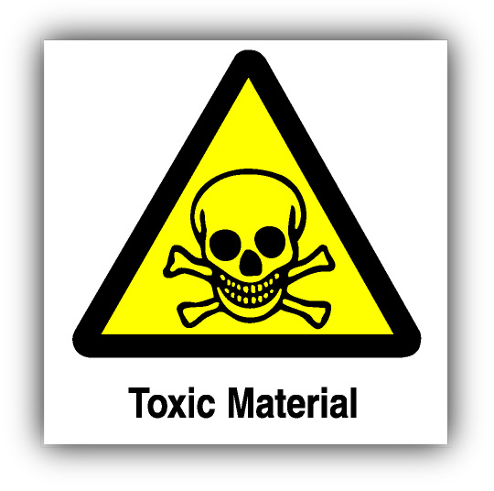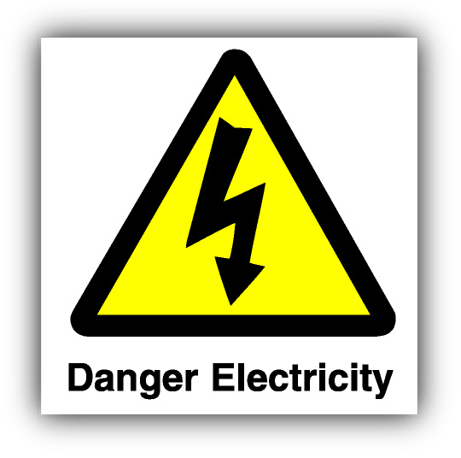

8 steps to COSHH assessment?
Employers should assess substances that are hazardous and provide information to employees. The COSHH assessment is also likely to result in control measures being recommended. The 8 steps to COSHH assessment are as follows:
Remember - exposure should always be prevented but if this is not possible the following actions should be implemented:
- Inform and train employees
- Apply clear hazard signs
- Reduce the amounts used
- Improve ventilation
- Reduce exposure
- Control access
- Label clearly
- Provision of protective clothing/equipment
- Suitable containers for all substances

Once any of the above have been identified as appropriate actions, they must be implemented and reviewed regularly.

The Chemicals (Hazard Information Packaging for supply) Regulations 2002 (as amended) (CHIP3)
These regulations are concerned with ensuring that when hazardous substances are packaged, they are properly packed and labeled. Also, that safety information is provided to users. Labels can be the first point of investigation when carrying out an assessment of risk.
Suppliers of dangerous substances must provide customers with the following information:
- Name of the supplier
- Composition and identification of the substance
- Clear advice on how to handle, store and dispose of the substance
- Fire fighting measures
- First aid
- Personal protection and exposure controls
- Ecological effects
- Transport requirements
All data must be kept up to date and given to the customers before the delivery and be in the language of the country of the recipient.
Fire safety
The importance of fire safety awareness cannot be underestimated. Whilst many people are unlikely to become involved in an incident, there is always the possibility that they will and therefore understanding the safest and best ways to act will help to minimise the possibility of serious injury or even death.
In addition, understanding the preventative measures or the plans that could be implemented around and within work places will also help to protect people from the risks connected with fire and associated emergencies.
The Regulatory Reform (Fire Safety) Order is fire legislation which came into force in October 2006 and requires all companies to carry out their own risk assessment to ensure that they are compliant with the regulations.

If you discover a fire:
- Sound the alarm;

- Call the Fire Brigade

- Use an extinguisher if safe to do so and you are trained to use one;
- Evacuate the premises by the quickest and safest route;
- Never use the lifts;
- Go to the assembly point for a roll call;
- Never return to the building.
- Every employee should know what to do in the event of a fire and be given the correct information and training. Emergency procedures such as evacuation should be rehearsed regularly and all employees should know where the assembly area is.
- The design of any building should include adequate routes of escape. These should be clearly labelled with green and white signage and offer people the shortest, safest route to a place of safety.
- You should only return to a building once the fire service has given the clearance to do so.
- Stay calm
- Do not run or allow others to run
- Organise people quickly
- Assist those who cannot move themselves whilst directing those who can move themselves
- Use wheelchairs if you need to move people quickly
- If possible move the bed with the person in it

Protect so far as reasonably practicable
The law does not expect all risk to be eliminated, but people should be protected as far as ‘reasonably practicable’.

Practice Risk and Evacuation Assessment
Fire drills should be used to help you practice the ability to make a quick assessment of the people in your care at that time and in their location within the building. Some of them may already be in designated safe areas.
- the main fire hazards
- the available control methods (including extinguishers)
- a full fire evacuation plan

Familiarise yourself with Escape Routes in your building, work place
- Escape routes should meet the following criteria:
- Where two or more escape routes are needed, they should lead in different directions to places of safety.
- They need to be short and direct.
- Fire doors should be self-closing.
- There should be no obstruction on escape routes.
- Escape routes should be checked regularly.

In the event of a fire it is vital that you know what to do!

Lighting
Escape routes need to be well lit in case of a power failure which may be caused by the fire.

Signs
Exit signs must always be clearly visible indicating the escape routes. They should have directional arrows showing the route to be taken.

Do:
- know the fire plan, know your escape routes, know where the designated safe areas are, know the location of call points and the position of extinguishers
- know the specific dangers and hazards on your premises
- know what notices there are, what they say and what they mean

Don't
- store combustible materials in unsuitable places, such as boiler houses and corridors
- enter a room unless you are sure it is safe to do so tackle a fire unless you are confident that you can do so - without endangering your own life or the lives of others
- use a lift as a means of escape
- ever go back to a fire until you have received the "all clear" from the fire authority!
It is your duty and your responsibility to yourself and to others to be aware of the fire precautions and procedures at your work place. All clients and staff MUST be aware of the evacuation procedure and not become complacent about it - ‘COMPLACENCY KILLS’!

If in doubt - ASK!
When calling “999” ensure that you:
- speak slowly and clearly
- give your telephone number
- give your full address
- state what type of assistance you require
- are prepared to meet the arriving fire crew

Fire procedures & people with a disability
People with a disability need special consideration when planning emergencies. Employers should:
- Identify everyone who may need special help to get out
- Allocate responsibilities to specific staff
- Train staff to help with their colleagues
- People with impaired vision should be encouraged to familiarise themselves with the escape routes
- A ‘buddy’ system would be good
- Staff with impaired hearing may not hear the alarms. In this case, other forms of alarm need to be considered, such as lights or other visual signs
- Wheelchair users and others with impaired mobility may need help negotiating any stairs
- Consider possible escape routes

